Experiment No.: 06
Experiment Name: Implementation of Curve Fitting Methods (Linear Least Square).
Theory: The Linear Least Squares method is a statistical approach used to find the best-fitting line through a set of experimental or observed data points by minimizing the sum of the squares of the differences (residuals) between the observed values and the values predicted by a linear model.​
If we take a set of data points (x1,y1),(x2,y2),...,(xn,yn), we want to find the equation of a straight line of the form:
y=a+bx
Here, a is the intercept and b is the slope. The least squares criterion states that the best-fitting line minimizes the total squared deviation S:
$$S=\sum_{i=1}^{n}{{\left(y_{i}-a-bx_{i}\right)}^{2}}$$
By partially differentiating SS with respect to aa and bb and setting both derivatives to zero, we obtain the normal equations:
$$\left\{\begin{aligned}\sum{y_{i}}=na+b\sum{x_{i}} \\ \sum{x_{i}y_{i}}=a\sum{x_{i}+b\sum{x_{i}^{2}}}\end{aligned}\right.$$
Solving these two equations simultaneously gives values of aa and bb, forming the best-fit line. This principle can also be generalized to multiple linear regression where several predictors are involved. The method assumes that all measurement errors occur in the dependent variable y, while xx values are known exactly. It is grounded on the assumption that residual errors are random, normally distributed, and have equal variance.

Program:




Output:

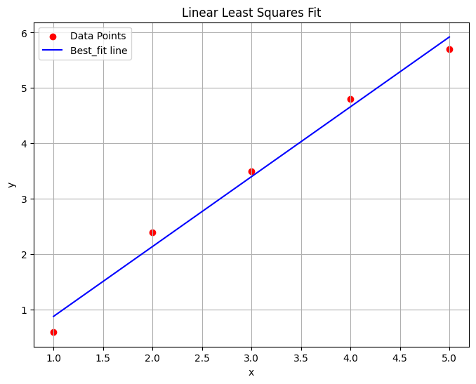

Discussion & Conclusion:
The Linear Least Squares method is an essential statistical tool used to find the line of best fit through data by minimizing the sum of squared errors. It is valued for its simplicity, accuracy, and computational efficiency, making it ideal for analyzing and interpreting data across fields like physics, economics, and engineering. Its main advantages include being easy to use, mathematically sound, and providing quick analytical solutions. However, it assumes linearity and is sensitive to outliers, which can reduce accuracy when the data is noisy or nonlinear. In summary, Linear Least Squares remains a fundamental and reliable technique for linear data modeling and serves as the basis for more advanced regression and curve-fitting methods used in modern analytics.

